|  |
| --- |
|  |
| Nursing Student Placement Process |
| Mercy Health Cincinnati Hospitals – Fairfield, West, Jewish, Anderson & Clermont |

|  |
| --- |
| Revised 2/2023 – Jewish Parking Info Change / J. Riggs |



**Clinical Group Placement Process**

Request for clinical placement should be placed into the Centralized Clinical Placement System (CCPS) by the school liaison:

<https://tristate.centralizedplacements.org/Account/Login>

**Note**: Request only needed clinical sites at each facility. For example: if you need 1 clinical for OB, please do not request multiple groups/days at Fairfield, West and Anderson. Requests will be reviewed by the School Placement Representatives group to best accommodate and ensure all requests received are granted equitable distribution.

**Role Transition Placement Process**

1. Schools will send their role transition request to the central mailbox ([Cincinnati-MH-NSP@mercy.com](mailto:Cincinnati-MH-NSP@mercy.com)) with the number of student requests, requested location, requested clinical area, time frame, date of request submission, number of clinical hours needed, and if the student is an existing Mercy employee (see Appendix A).
2. Student placement coordinators will review requests as a team at least 3-4 weeks prior to the earliest role transition start date.
3. Submission request dates will be considered when assigning role transition requests

**Required Documents**

Instructors and/or school liaison should access the Mercy Health Collaborative website <https://workforce.healthcollab.org/students/clinical-placement-for-nursing-students/mercy-health/> for documents that need to be completed prior to start date of clinicals which include:

* ***Student information and Epic Request Form –*** e-mail this form to all 3 places:

1. Mercy Health site coordinators (Laura, Robin, Lisa, Chelsea, and/or Amy)

2. Epic request mailbox [CIN-KY-Nursing-Schools@Mercy.com](mailto:CIN-KY-Nursing-Schools@Mercy.com) and

3. Covid central mailbox [covid_student@mercy.com](mailto:covid_student@mercy.com)

* + ***All Sites Mercy Health Confidentiality and Security Agreement***– each clinical instructor must submit a signed agreement to [CIN-KY-Nursing-Schools@Mercy.com](mailto:CIN-KY-Nursing-Schools@Mercy.com), student agreements remain on file with school
* ***Nursing Instructor Department Orientation Checklist***- completed with NPDA or unit manager / coordinator / supervisor during first clinical rotation at site

BSMH COVID-19 STUDENTS/FACULTY VACCINATION VALIDATION PROCESS:

**Bon Secours Mercy Health Student/Faculty Vaccination Policy, Tracking and Exemption Process**

**Policy Guidance:**

In compliance with the federal COVID-19 policies ([click here to read the CMS guidance](https://nam11.safelinks.protection.outlook.com/?url=http%3A%2F%2Fleadercriticalupdate.us.newsweaver.com%2F1slssxmlyy%2F1ibq4peswsrtbaeo5atyea%2Fexternal%3Femail%3Dtrue%26a%3D5%26p%3D8776360%26t%3D1268477&data=04%7C01%7CPamela_Hash%40bshsi.org%7C26b19c8056fa4042fed608d9ed91fb95%7Cbb84ecdc9a5141eb880c178c5153d561%7C0%7C0%7C637802033516095031%7CUnknown%7CTWFpbGZsb3d8eyJWIjoiMC4wLjAwMDAiLCJQIjoiV2luMzIiLCJBTiI6Ik1haWwiLCJXVCI6Mn0%3D%7C3000&sdata=4ifQyYz6pEwoayqj8fZ50SSmEapHn4QaYYFMX%2FxSqUA%3D&reserved=0)), all Bon Secours  Mercy Health (BSMH) associates, including affiliate providers, medical staff, remote workers, as well as students, vendors, contractors and volunteers, are required to be fully vaccinated, or have an approved exemption.

BSMH expects affiliate schools to track student/faculty vaccination compliance and provide requested vaccination compliance reporting (within 4 hours of request during a regulatory compliance survey) in accordance with CMS mandate and NHSN reporting requirements via [COVID_student@mercy.com](mailto:COVID_student@mercy.com).

**Managing Documentation of Vaccinations and Exemptions:**

BSMH does not automatically manage affiliate school vaccination processes, including exemptions. It is our health system’s expectation that affiliate schools will have a process in place to ensure students and faculty who must attend clinical placement experiences at a BSMH site will have documentation of required vaccines or an approved medical or sincerely held religious belief exemption that has been reviewed and approved by the School consistent with the requirements of the CMS regulation.

BSMH expects students and faculty to submit via [covid_student@mercy.com](mailto:covid_student@mercy.com) email address, PRIOR to clinical start:

* Proof of full vaccination according to current CMS standards
* Documentation of approval for exemption for medical or sincerely held religious beliefs OR
* Application for approval of exemption from BSMH using approved forms (please request).

If you are NOT fully vaccinated according to current CMS standards, you must complete vaccination prior to starting a clinical experience or receive an approved exemption.

BSMH continues to provide COVID-19 vaccines through the local market and retail pharmacies. The COVID-19 vaccination is also widely available in the community making it convenient to receive.

**Request for Exception for Managing Student/Faculty Vaccination Processes for Affiliate Schools**

In the event an affiliated school needs support for managing vaccination tracking or exemption processes, BSMH has a toolkit to offer guidance to help schools to develop their own process. If a school is unable to manage their own vaccination tracking or exemption process, if agreed by BSMH and school and set forth in the applicable school affiliation agreement, the school may request an exception from local executive leadership, wherein BSMH will review and approve or deny requests for exemption (See attachments). Students and faculty requesting exemption will be notified by email submitted on exemption form within 10-14 days of submission of a **completed** form. Incomplete forms will not be processed. Should you need this exception, please reach out to BSMH leadership for assistance.

**What Happens if I Don’t Receive the Vaccine?**

Students and faculty who choose not to meet the requirement, by either becoming fully vaccinated according to current CMS guidelines or with documented approval of exemption will NOT be able to participate in any clinical experiences at BSMH. Documentation must be submitted and reviewed prior to attending first day of clinical experience or the student or faculty will not be able to participate. Please review the Federal COVID-19 policies ([click here to read the CMS guidance](https://nam11.safelinks.protection.outlook.com/?url=http%3A%2F%2Fleadercriticalupdate.us.newsweaver.com%2F1slssxmlyy%2F1ibq4peswsrtbaeo5atyea%2Fexternal%3Femail%3Dtrue%26a%3D5%26p%3D8776360%26t%3D1268477&data=04%7C01%7CPamela_Hash%40bshsi.org%7C26b19c8056fa4042fed608d9ed91fb95%7Cbb84ecdc9a5141eb880c178c5153d561%7C0%7C0%7C637802033516095031%7CUnknown%7CTWFpbGZsb3d8eyJWIjoiMC4wLjAwMDAiLCJQIjoiV2luMzIiLCJBTiI6Ik1haWwiLCJXVCI6Mn0%3D%7C3000&sdata=4ifQyYz6pEwoayqj8fZ50SSmEapHn4QaYYFMX%2FxSqUA%3D&reserved=0)), for more detailed information.

**Regulatory Reporting Requirements**

BSMH is required to report vaccination status of associates and non-associates (i.e. students) to different regulatory and compliance agencies in the required format.

* Reporting during CMS represented compliance surveys (i.e. The Joint Commission, Department of Health) require a **roster of individual student/faculty** working in the facility. BSMH has requested a monthly report submission via email at [covid_student@mercy.com](mailto:covid_student@mercy.com) until a technology enabled solution can be implemented.
* BSMH personnel will reach out to our university/college points of contacts should a surveyor require specific information about a student or faculty member with an expectation of a four hour response.

**Technology Enabled Processes**

BSMH is currently implementing a technology solution that will help automate and streamline clinical placement scheduling, compliance requirements, reporting of vaccination status and allow upload of exemption forms.

**For Epic Access:**

Please provide the following to Mercy Health EPIC central mailbox- [CIN-KY-Nursing-Schools@Mercy.com](mailto:CIN-KY-Nursing-Schools@Mercy.com)

Please use the ***Student information and Epic Request*** form and submit to the Mercy Health EPIC coordinator for access at least 30 days prior to starting **all** clinical rotations at any Mercy Facility.

**EPIC Training: Students**

* All students must attend a 1-hour virtual training session prior to arriving on campus for first rotation. Attendance is a one-time event for all clinicals at Mercy Health.
* Attendance is mandatory will be taken in the virtual classroom.
* Training sessions are via Zoom and accessed via a desktop or laptop for visual. Audio is available either through the computer or by phone.
* Classes are offered every Wednesday at 1 pm and Thursday at 4 pm (except holidays). There is no need to sign up in advance. Class offerings and Zoom link are attached.

**EPIC Training: Instructors:**

* All instructors new to Mercy Heath must attend the same 1-hour virtual training session prior to arriving on campus for first rotation. Epic accounts will be unlocked after completion of training.
* Instructors must have completed training before students will be granted access.
* Instructors that are Mercy Health nurses working inpatient areas, already have access and do not need to attend.
* Training sessions are accessed via a desktop or laptop for visual. Audio is available either through the computer or by phone.
* Classes are offered every Wednesday at 1 pm and Thursday at 4 pm (except holidays). There is no need to sign up in advance. Class offerings and Zoom link are attached.

**Clinical Instructors:**

**E-mail the central mailbox**[**CIN-KY-Nursing-Schools@Mercy.com**](mailto:CIN-KY-Nursing-Schools@Mercy.com) **and site coordinator below the week before your clinical starts with a request for student log in information (include student names and first date on unit)**. You will be e-mailed back your student’s information, please keep this confidential. Passwords may be changed on the unit. To change challenge answers, you will need to be in a designated computer space with secure computers. Many sites have open computer rooms to use. Onsite classroom time can be arranged, please reach out to central mailbox [CIN-KY-Nursing-Schools@Mercy.com](mailto:CIN-KY-Nursing-Schools@Mercy.com) and site coordinator below.

**Mercy Health Site coordinators for clinical placement**

* + **Mercy Health - West:**    Robin Fox [RXFox@mercy.com](mailto:RXFox@mercy.com)
  + **Mercy Health - Fairfield**:  Laura Davis [LNLeeds@mercy.com](mailto:LNLeeds@mercy.com)
  + **Mercy Health - Anderson**:  Jennifer Riggs [JRiggs@mercy.com](mailto:JRiggs@mercy.com)
  + **Mercy Health - Clermont**:  Amy Jackson  [AJJackson0@mercy.com](mailto:AJJackson0@mercy.com)
  + **The Jewish Hospital:**  Lisa Masterson [LMMasterson@mercy.com](mailto:LMMasterson@mercy.com)

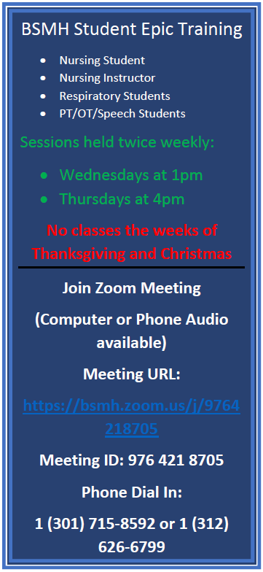

**BSMH Student Epic Training**

**2023**

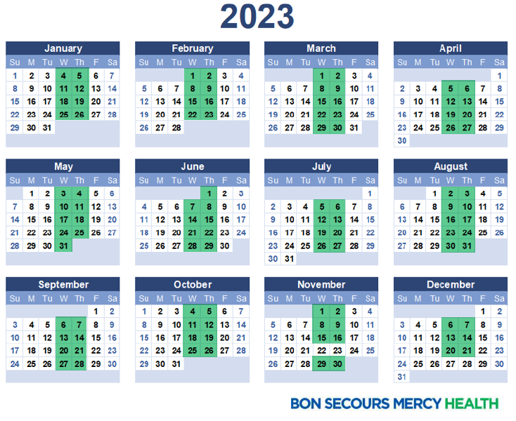

**Instructor Orientation/Shadowing Expectations**

Instructors new to Mercy Health, are required to schedule orientation on the unit with the NPDA or unit manager at least 2 weeks prior to the start of the clinical.

Checklist for instructor orientation

* EPIC training / Password changes.
* Omnicell
* Badge information
* Locate and review the following
  + Emergency exits
  + Fire extinguishers
  + Crash cart
  + Med/supply room
  + Nutrition
  + Call light system in patient rooms
  + Orientation to patient room, and safety measures
  + Assignment sheets and recommend practices for making assignments, including communication of student assignment
  + Resources personnel (ie Manager, Unit Clerk, Charge Nurse)
  + IV pumps
  + Contact charge nurse if canceling clinical
* Shadow RN on unit
  + For new instructors to teaching the recommendation is 2-4 hours
  + For instructors new to Mercy the recommendation is 2-4 hours.
  + For instructors not new Mercy, but new to the unit the recommendation is 1-2 hours.
  + Please schedule the amount of time to help you be successful with your students.

**Guidelines for Direct Patient Care Student**

*Welcome to Mercy Health!* We certainly hope that your educational experience is rewarding. This guideline serves as a resource to you as you begin your clinical experience with us.

**Standards:**

Student is held to the standards of a competent professional when performing clinical duties.

**All preboarding requirements and documents are coordinated and collected by the school, prior to the start of the clinical rotation. Ensure to familiarize yourself with the pre-boarding requirements listed on the healthcollabortive website:** <https://workforce.healthcollab.org/students/clinical-placement-for-nursing-students/mercy-health/>

**Uniform/Badge:**

Student is to wear appropriate school uniform, school nametag, and Mercy Health student badge (as applicable) while in clinical area. Your school’s Instructor/ Student Placement Coordinator will provide MH student badge (as applicable to site). Return your MH badge to your instructor, per market procedure. Report any lost or stolen badges to your Instructor/ Student Placement Coordinator immediately. Your school may require you to pay the replacement fee for a lost badge.

Student is to follow BSMH Appearance Policy regarding personal hygiene, jewelry, fingernail management, and footwear. A student found in violation of this policy can be sent home.

**Attendance:**

Students must track their attendance, as required by clinical instructor and/or market/site.

**Reporting Off for Illness:**

Student is to report off to their Instructor/Preceptor and their respective unit / department. Please leave your name, name of school, Instructor’s name, and reason for reporting off.

**Clinical Responsibilities:**

* **Report**- Student is to receive a patient report to find out their patient’s needs, scheduled tests, lab results and condition. It is imperative that the student notifies the RN responsible for the patient when there is a change in the patient’s condition or a problem arises with equipment. Student (i.e. nursing) must report off to the patient’s RN when leaving the dept. or at the end of the clinical day.
* **Infection Prevention Principles**- Student is to follow organization Infection Prevention policies with regards to standard precautions, hand washing, PPE, and transmission-based precautions.
* **Medications-** A student permitted to administer medications is to demonstrate safe medication practices. This includes knowledge of the six rights to medication administration, medication actions, safe dosage for adults, seniors and children, side effects and special considerations for administration. **Student is only permitted to administer those medications allowed by their scope of practice and in the presence of their Instructor/Preceptor.** Unlicensed providers do not get access to the medication dispensing system, all medications will need to be removed by their preceptor or instructor.

**Certified / licensed Instructor / Preceptor** will check ALL medications prior to student administration. Select medications must be double checked by two licensed individuals prior to administration. This may include, but is not limited to, the following medications; insulin, anticoagulants or any weight-based medications. ALL intravenous medications are to be prepared and administered under the direct supervision of a certified professional / licensed nurse. **A student may not administer Chemotherapy, IV push cardiac medications, neuromuscular blocking agents, epidurals, patient-controlled analgesia (PCA), or administer blood products.**

* **Clinical Skills/Procedures**-The Instructor/Preceptor must be present to supervise if the student has not attained clinical competency in a procedure. Instructor/Preceptor will provide guidance about which skills may be performed independently.

*Student is to use two patient identifiers (Patient Name and Birth Date) when providing any clinical intervention.*

* **Blood Glucose** – access is unable to be granted to instructors or students due to CLIA waived testing restrictions
* **Documentation**- Documentation must be reviewed by the Instructor/Preceptor prior to entry into the Electronic Medical Record (EMR). Student is to attend a computerized clinical documentation course, provided by their Instructor or MH Credentialed Trainer, prior to documenting in the EMR. All entries are to be co-signed by Instructor/Preceptor. Only licensed employees can fill our and witness informed consents.
* **Physicians Order-**Student is not permitted to receive telephone or verbal orders. Transcription of orders is permitted only in an approved preceptorship or management course.
* **Personal Health Information**-Student may NOT copy/take identifiable patient health information or any part of the patient’s EMR off the unit at the conclusion of their shift.
* **Cellphone Usage**- The usage of personal cell phones in patient areas is prohibited for instructors and students. If a phone needs to be referenced, it should be in non-patients facing area.
* **Chain of Command**- Instructors and students must follow the chain of command for issues and safety events, including but not limited to patient’s primary nurse, charge nurse, manager, and patient’s primary physician if applicable. Report safety events and near misses through ***Safecare*** located on Central, please engage your chain of command to complete the report.
* **Injury on Duty-** If an injury occurs, inform instructor and designated site Nursing Leader, as appropriate, immediately. The instructor/student may need to report to the Emergency Room.
* **Non-English-Speaking Patients-** We are required to use a certified interpreter-translation services. Notify instructor/charge nurse if this is encountered.
* **Instructors, employed by Mercy Health**- when at clinical as an instructor (employed by the school of nursing), must provide care as an instructor and not as an employee. The instructor may need to defer some aspects of care and decision-making to the patient’s primary nurse.

**Student Parking Rules**

**Jewish:** Park in Kenwood Mall lot (arrowing indicating parking location), walk over as a group observing crosswalk rules.

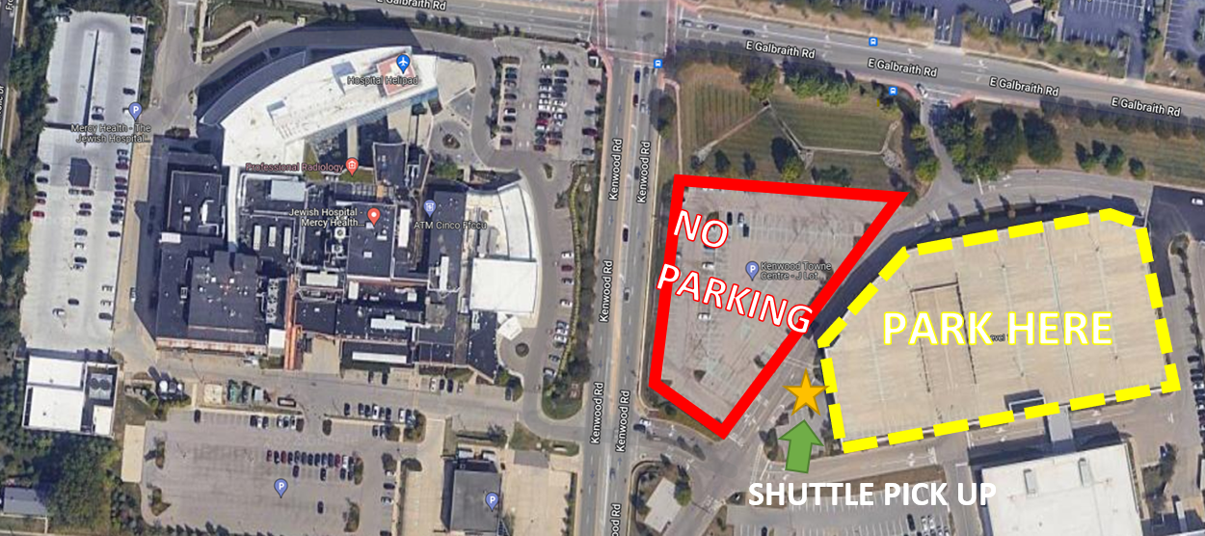

**West:** Park in employee lot during day shift (large square indicating location) or lower level of garage for night shift (small rectangle indicating location).

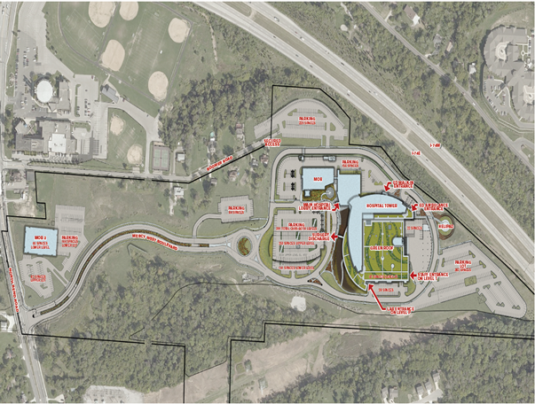

**Fairfield:** Park in dedicated employee parking areas near front of building row F and beyond. Avoid parking near dock area, badge access is required over there.

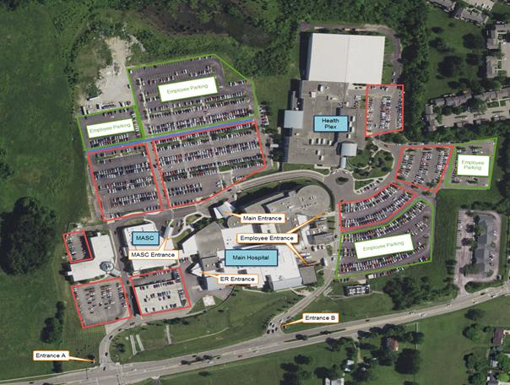

**Anderson:** Park in dedicated employee parking areas near front of building, avoid back lot due to badge access required.

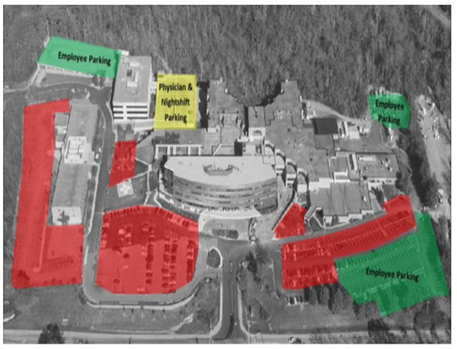

**Clermont:** Park in dedicated employee parking areas near front of building.

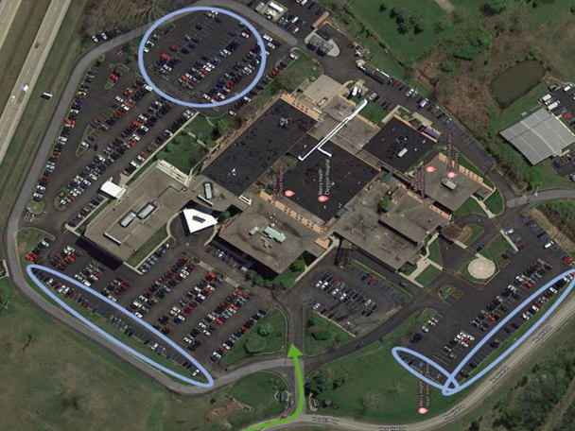

Mercy Health is not responsible for any damaged or stolen vehicles. Locking vehicles and placing valuables out of view will enhance security.

***There is no smoking, including Vapor and electronic devices, on any MH property including your vehicle parked in MH parking lots.***

Appendix A

**Request for Role Transition Clinical Placement at**

**Mercy Health Cincinnati Hospitals**

**Name of School:** ______________________

**Date Requested**: **Date Fulfilled**: _______________

**Mercy Site Requested:** Anderson Clermont Fairfield Jewish West

**Type of Program:** AD BSN ABSN Master Other: _

**Dates of Role Transition:** **Start** _________________  **End**: ____________________

**Total number of Hours required:** ___________________

**School Liaison name and contact information:** ______________________

**Email**: _____________________

**Are students permitted to care for COVID patients?** Yes No

**Are any of the students current Mercy Employees?** Name & Current Site/Unit:

____________________________________________________________________________

**Number of requests:**

|  |  |  |
| --- | --- | --- |
| **Type of Unit** | **Number of requests** | **Special Requests** (if placing at multiple sites include # & site. Ex: 3 – Fairfield & 3 – Jewish) |
| ICU |  |  |
| CVU |  |  |
| PCU |  |  |
| Family Birth Center |  |  |
| Progressive Care |  |  |
| Med/Surg |  |  |
| Pre/Post |  |  |
| Cath Lab |  |  |
| OR |  |  |
| ED |  |  |

Send Role Transition request to [Cincinnati-MH-NSP@mercy.com](mailto:Cincinnati-MH-NSP@mercy.com) at least 2 months prior to placement request. We will do everything we can to accommodate requests.

Appendix B

**Department Orientation Checklist**

**Nursing Instructor**

**Name:**  **School Name:** _____________________

**Employee:** Yes No **Returning Instructor:** Yes No

**Date of Initial Orientation:** **Department/Site:**

Directions: Each new nursing instructor receives a department orientation that is consistent, planned and supervised by unit designee. You should be introduced to your preceptor during your first few hours of shadowing experience.

The following list is to serve as a **guide** for you as you begin your department orientation. Check each item off this list as it is explained to you or discussed. This is the best time to ask questions and clarify issues which are of the most concern to you as a new instructor. No question is insignificant.

**PRIOR TO NEW CLINICAL START DATE**

* Epic IT request placed (Must have Employee’s last 4 digits of SS#)
* Attend the 1 hour virtual training session prior to arriving on campus for first rotation.
* Contact the School Placement NPDA at least 2 weeks before clinical start date to discuss orientation.
* Confirm the following forms have been provided to the site by from the school prior to clinical start.
* Student information and epic request form
* All Site Mercy Health Confidentiality Agreement

**INSTRUCTOR AND STUDENT RESOURCES**

* Health Collaborative Workforce Site: <https://workforce.healthcollab.org/students/clinical-placement-for-nursing-students/mercy-health/>
* Important information for students and instructors

**DEPARTMENT STRUCTURE**

* Introductions to manager, charge nurse
* Who to go to with problems and concerns, chain of command.

**DEPARTMENT DESCRIPTION**

* Understand who are our customers- patients, students, and nurses
* Instructor and Student responsibilities and workflow
* Tour of the department

**CLINICAL SCHEDULE**

* My clinical rotation schedule dates- any exceptions noted
* Handling special requests- Shadowing in other departments

**PERSONAL BELONGINGS**

* Where to store personal belongings
* What is appropriate to wear and not to wear/appropriate footwear
* Name badge as part of uniform- How to sign in and out
* Omnicell access

**COMMUNICATION**

* Posting Daily Assignment expectations
* Within 30 minutes of start of clinical day
* Outlines all responsibilities for the students for the day, i.e. med passes, beds/baths, rounding
* Personal Phone Calls
* Who to contact when late or absent
* Report- beginning of shift and end of shift

**CUSTOMER SERVICE/QUALITY IMPROVEMENT**

* What do our customers expect from us
* Instructor and student’s role in improving quality- Unit specific

**MANDATORY EDUCATION AND TRAINING**

* BSMH Central
* Documentation-and why it is important. (Co-signature of student charting)
* Location of resource manuals:

_____ MSDS

_____ Infection Control

_____ Emergency Preparedness

_____ Department Policies and Procedures

* Infection Control (as appropriate for department)

_____ Location and use of personal protective equipment

_____ What to do in the event of a needlestick or exposure incident

_____ Department specific infection control policies & procedures

* Safety (as appropriate for department)

_____ Fire safety

_____ Hazardous materials

_____ Unit equipment

_____ Fall Prevention

_____ Back injury prevention- LIFT Equipment- Maxi Slides and Steady (Sara Steady)

The Unit designee and I have reviewed all the material on this checklist. I am aware of the resources, materials and people in my department and in my facility.

New Instructor Signature Date

Manager / Clinical Coordinator Signature Date