**EPIC E-LEARNING INSTRUCTIONS**

EPIC is a computerized clinical information-management system designed to manage client-specific data and information at many Tri-State hospitals and medical facilities. Nursing students who will be participating in a clinical experience at a member hospital must complete several E-learning modules**.** Once the e-learning modules have been completed at one hospital, they are accepted at the other hospitals as well.

**Access Instructions:**

To **access the modules from onsite**, use a hospital computer and go to the intranet (type “intranet” in the address bar), and follow the directions below starting on page 3. For onsite completion, no student access is required.

To **access the modules from off-site**, the student must have a St Elizabeth student ID and password. The school coordinator must complete and submit the online SARS request to SEH IS/IT department. The student’s access number will be sent to the coordinator or instructor who submitted the form. The student must use this access number and password for access through the website <https://stelizabethhealthcare.sharepoint.com/sites/connection>(specific instructions on next page.)

Initial password is the students last 4 digits of the Social Security Number with the word Welc@me “W “is a capital letter. Example 9999Welc@me, with “Last4SS” representing the last for digits of the user’s social security number. (Important to note, the “o” in Welcome is replaced with “@”)

Students will be required to change their password with first login. Recommended secure password is 8 characters with at least 1 upper case letter and one number or symbol.

Once all modules have been completed, the student must take the “Epic Student Test”, and a school instructor/coordinator must grade the test. Passing grade is 80% or higher. This test will be kept on file at the school.

Completing the following five modules will take approximately two to three hour’s total.

**Required modules:**

*These can be done over any number of online sessions, and your learning will probably be more effective if you complete them over multiple shorter sessions rather than all at one time. Also, each module can be viewed as many times as you wish to do so.*

***These 3 modules are required for all participating Tristate hospitals:***

CLNINP001 Overview of Hyperspace for an Inpatient Setting (2019 version)

INP061 Documenting in Flowsheets (2019 version)

INP062 Administering Medications on the MAR (2019 version)

***This 1 module is required for St Elizabeth Healthcare:***

INP 080 Using Pump Rate Verify (2019 version)

***INSTRUCTORS ONLY:***

INP162 Documenting Scheduled, Overdue, Missed, and Held Medications and Override Pulls (Version 2017)

**Suggestions for troubleshooting problems from offsite computers** -

**Must have an EPIC User-ID to get into the site.** <https://stelizabethhealthcare.sharepoint.com/sites/connection>

1. Must have completed the AZURE 2nd form of Identification instructions located on page 3
2. Added *.stelizabeth.com to trusted sites
3. Use Internet Explorer, e-learning works less well on Netscape, Safari, or Firefox. (I could not get it to work on Internet Explorer at all, but it did work on Firefox for me.)
4. Turn off pop-up blockers. This feature may interfere with the e-learning modules since the Application Access window must be open and you must allow it to activate JAVA™ Platform SE6U.
5. Turn off extra toolbars.
6. Clear your browser cache (history) (temporary internet files).
7. Enable SSL and TLS protocols. Under internet options, go to advanced, check SSL and TLS.
8. May need to use a lower browser such as Internet Explorer 9 or 10 for viewing these modules. Under intranet tools, developer tools, browser mode (select IE 9 or 10). Several of the intranet features may not be compatible with the higher browsers.
9. Need Java and Cisco (most updated version) since these are interactive modules.

If you have attempted to access the e-learning modules with your EPIC training access ID, have gone through all the troubleshooting suggestions above, and your IS department has tried and cannot get it to work, you can have them contact our IS department at 301-2541. They may be able to give suggestions, but they are not allowed to work on non-St Elizabeth computers.

If you continue to experience problems with offsite access, please schedule a computer classroom through Sue Watkins ([Sue.Watkins@stelizabeth.com](mailto:Sue.Watkins@stelizabeth.com) for SETEC; ([nsdc@stelizabeth.com](mailto:nsdc@stelizabeth.com)) for Florence or Ft Thomas for students and/or instructors to come onsite to complete the e-learning. When scheduling, please include several available dates and timeframes, as well as the total number of computers, and preferred site (this does not guarantee that site would be available but is helpful for a start) needed since this will affect which room is scheduled.

EPIC and St Elizabeth require that those with access to EPIC have completed training and a test. We **cannot allow students or instructors without training to document**. To access EPIC e-learning from one of our campuses, it is not necessary for the students to have EPIC access since they would be accessing our nonproduction environment for training purposes.

I apologize for the difficulties this may cause, but currently there is no easier means of training the students. Please remember, if the students have completed EPIC training through one of the other hospitals participating in this EPIC training agreement through the GCHC, with the **4** required modules and test, we accept that training and test, they are essentially the same. **The one additional module St Elizabeth requires is the** **INP 080 Using Pump Rate Verify (2019 version), since students are permitted to give IV meds here at St Elizabeth.**

**Steps for accessing EPIC e-learning modules from offsite** – MUST have completed the second form of authentication, AZURE, instructions are embedded below.



Go to <https://stelizabethhealthcare.sharepoint.com/sites/connection> log in using your EPIC access username and password. This EPIC access will only allow you to access the intranet, but you will not have access to EPIC until you have completed the e-learning modules and resubmitted the EPIC access SARS request form indicating completion of EPIC training.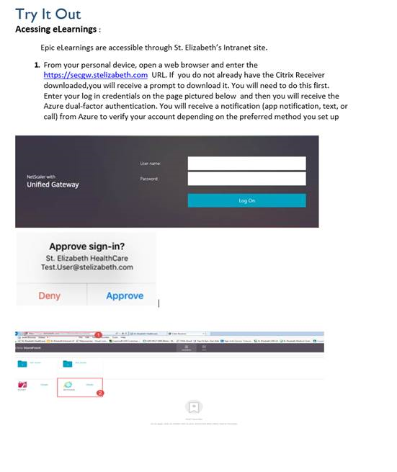

1.Click the SEH Sharepoint

2.Hover the mouse over NURSING

3.Click on EPIC > EPIC E-learning

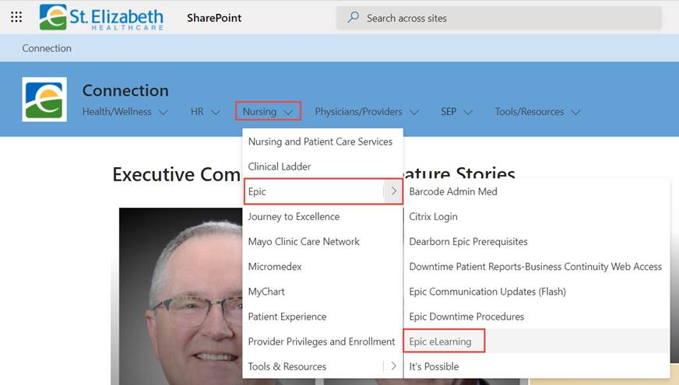

4.Nursing Students and Instructors select: INPATIENT CLINICAL.

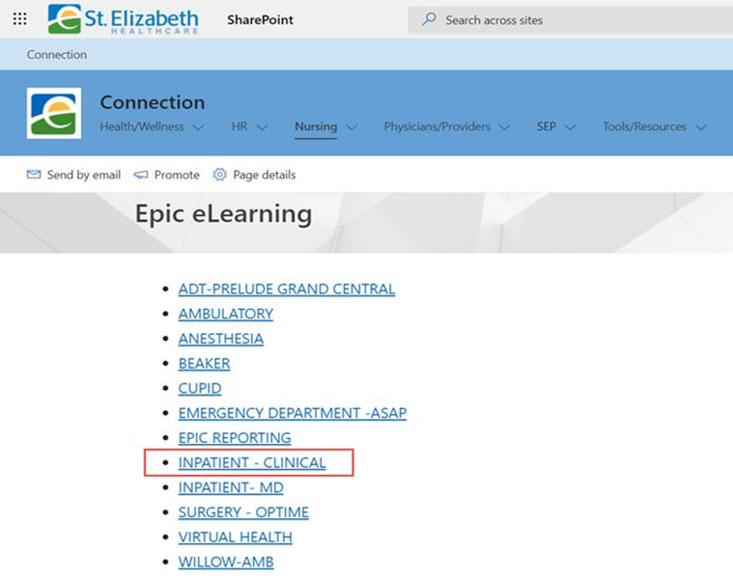

Select and complete all 4 required NURSE modules

CLNINP001 Overview of Hyperspace for an Inpatient Setting (2019 version)

INP061 Documenting in Flowsheets (2019 version)

INP062 Administering Medications on the MAR (2019 version)

***This 1 module is required for St Elizabeth Healthcare:***

INP 080 Using Pump Rate Verify (2019 version)

**INSTRUCTORS ONLY** INP162-2017 Documenting Scheduled, Overdue, Missed, and Held Medications and Override Pulls